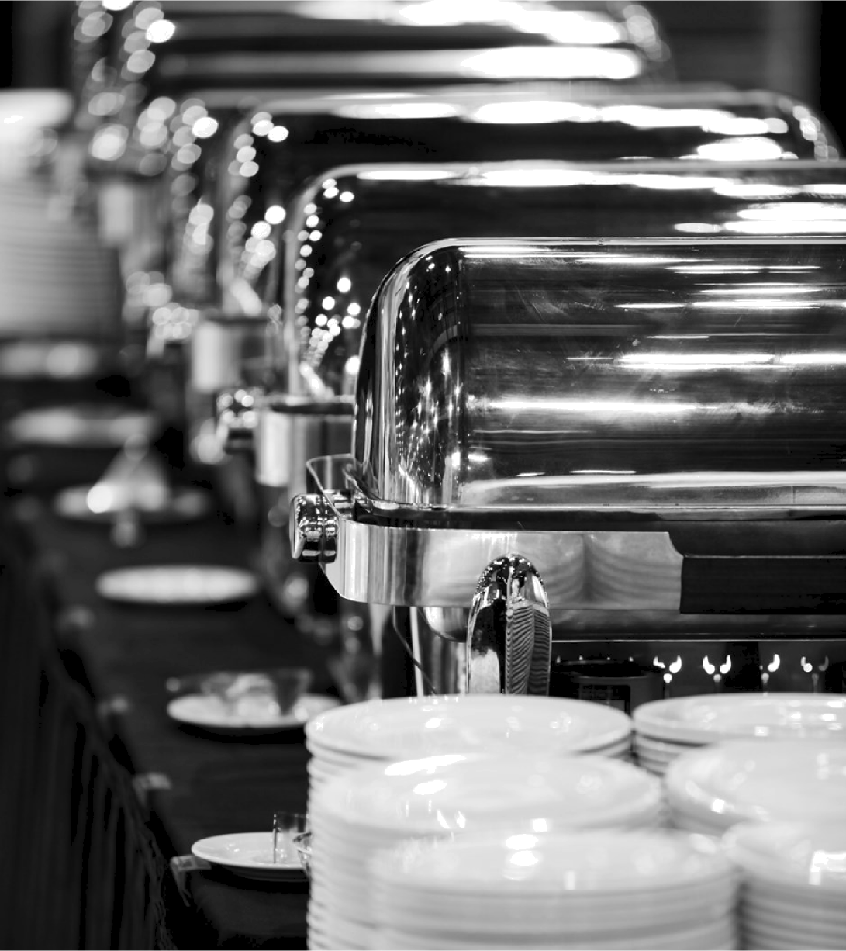

St. bans Sports

Frequently Asked Questions

How many guests can I have?
We can cater for between 30 and 120 guests. Cocktail functions start from a minimum of 30 guests and can go up to a maximum of 120 guests. Sit-down set menu functions start from a minimum of 20 guests and can go up to a maximum of 80 guests.

Will we have the room to ourselves?
Yes! The function room is completely private and your function will have its own dedicated bar and service staff. (Please note for functions smaller than 50 guests there may be some changed conditions. Please check with your function coordinator).

Are there special prices for children and are they welcome?
Yes, children’s meals come at a reduced price, and they are more than welcome!

Can I set aside a date while I decide?
Yes! We offer you an obligation free tentative booking for 7 days in conjunction with a firm offer tailored to your specific requirements. You can also use this time to check that our package represents the best value to you.

How long can my function last?
Our standard options are a generous 5 hours, with our function room licensed up until 12am last drinks will be called at 11:30pm. Luncheons or smaller events are 4 ½ hours, with extra time as an option.

What about the cake?
We’ll store your cake, present it when required and cut it for you at no extra charge.

Are there additional services you offer?
Please speak to our Functions Coordindator about any of the additional services we offer.

Our advice
Ready-To-Go Platters
Approximately 45 Pieces per Platter (Vegetarian Platters Available Upon Request)

This style of finger food is best suited for a relaxed, no fuss style of function. The Ready-To-Go Platters make planning your occasion quick and easy. As a guide, we recommend allowing approximately one platter for every ten people attending your function.

$80 platters
- Choice of Chicken Wings:
  - Crispy Fried Spicy
  - Honey and Soy
  - Buffalo

$90 platters
- Gourmet Sandwiches or Wraps
- Fresh Seasonal Fruits

$90 platters
- Choice of Savoury:
  - Party Pies
  - Party Sausage Rolls
  - Mini Quiches
- Choice of Asian:
  - Mini Dim Sims
  - Mini Spring Rolls
  - Curry Puffs
  - Crumbed Prawn Cutlets
- Cheese Selection:
- Local Cheeses
- Dried Fruit
- Nuts
- Savoury Crackers

$110 platter
- Selection of Mini Desserts

$140 platters
- Homemade Assorted Gourmet Sushi
- Homemade Gourmet Rice Paper Rolls
- Choice of Gourmet
  - Fish Goujons
  - Satay Beef Skewers
  - Lamb Kofta
  - Crispy Chicken Wings
  - Grilled Prawns

$100 platters
- Chicken Nuggets

$75 platters
- Chips

$80 platters
- Wedges

Notes:

Set Menu
(Minimum 40 guests)

2 Courses $40 per person 3 Courses $50 per person

Entrée + main or main + dessert Entrée + main + dessert

Entrees:
  - Dill and Pink Peppercorn Cured Salmon, Warm Leek and Potato Salad with a Creamy Mustard Dressing
  - Crispy Skinned Barramundi Fillet on Asian Rainbow Slaw with a Chilli Caramel Dressing
  - Honey Mustard Warm Chicken Salad with Fennel, Orange Segments and Snow Pea Tendrils
  - Chicken Penne with Bacon, Red Capsicum and Rosé Sauce
  - Soup of Your Choice:
    - Roast Honey Pumpkin
    - Potato, Leek and Bacon
    - Creamy Chicken and Corn
    - Dahl and Pappadum

Mains:
  - Braised Beef Bourguignon with Mushrooms, Pearl Onion, Lardons of Bacon and Carrot Batons with a Creamy Potato Puree
  - Grilled Rump Eye Fillet on a Warm Saffron, Chat Potato, Chickpea, Chorizo and Fennel Salad with a Caramelised Orange Dressing and a Fine Herb Salad
  - Roast Pork Belly on a Stack of Roast Vegetables with a Port Wine Jus
  - Chargrilled Basil and Lemon Chicken on a Bed of Pea Risotto with Grilled Aspar- agus Spears
  - Roast Oyster Beef served on Garlic Mashed Potato and Sautéed Green Beans with Mushroom Sauce
  - Dukka Spiced Chicken Breast on a Cous Cous Salad with Zucchini Ribbons, Yo- ghurt Cream and Pomegranate Dressing
  - Grilled Haloumi Cheese, Eggplant and Red Capsicum Salad with Harrisa Sauce

Desserts:
  - Sticky Date Pudding with Caramel Sauce and Double Cream
  - Lemon Meringue Tartlet with Passionfruit Pulp and Mint
  - Warm Apple Crumble with Vanilla Ice Cream
  - Free Form Pavlova with Strawberries, Kiwifruit, Passionfruit Coulis and Crushed Pistachios
  - Baked New York Cheesecake with Mixed Berries
  - Flourless Chocolate Cake with Chocolate Ganache

Kid’s Meals
Set Menu

For Children 12 years and under. All children’s meals come with free soft drink and ice-cream

Additional Information
All meals will be served with warm bread rolls All set menus are served as an alternate drop
All steak dishes are cooked to medium unless specified otherwise by client Vegetarian and special dietary menus are available on request

Notes:

Terms & Conditions

Dietary Requirements:

All dietary requirements are to be sub- mitted and confirmed at the time of the final food payment, 14 days prior to the event. All food and beverages consumed during the function must be supplied by the St Albans Sports Club, with the ex-
ception of a celebration cake.

Price & Minimum Spends:

All prices quoted are inclusive of GST. Whilst every effort is taken to maintain prices, these are subject to change.
There is a minimum spend required for the function room. The minimum spend is restricted to food and beverage only.
Any costs outside of this (e.g. additional security, entertainment) are not included in the final calculation. If the minimum spend quoted for the room is not met, a room hire fee will be added. Minimum Food spend for 20-50 people: $400 Mini- mum Drink spend for 20-50 people: $450 Minimum Food spend for 50-100 people:
$600 Minimum Drink spend for 50-100 people: $700.

Final Payment:

All catering requirements are to be made at least fourteen (14) days prior to the date of your function. Final numbers are required seven (7) working days prior to the event. Please note that this number will form the basis for final charging. If payment is not received, the venue re- serves the right to cancel the function.
Any drink tab must be paid in full upon conclusion of function.

Confirmation of bookings:

Due to demand, tentative bookings can only be held for up to seven (7) days.
Once this period has lapsed, the venue
reserves the right to release the tentative reservation. To confirm a booking, a min- imum deposit of $200 is required. This payment should be made within seven
(7) days of booking to secure the date;
this can be made using a credit card, eft- pos or cash. A driver’s license is also re- quired to confirm the booking and is photocopied as security. The $200 de- posit will be used as the bond.
Guest Entry:

Guest entry to the function will only be permitted in accordance with agreed start and finish times. St Albans Sports
Club is a licenced venue that requires all Non-Members to sign in upon entry. The venue reserves the right to refuse entry to any patron in accordance with normal responsible service of alcohol proce-
dures. Minors are welcome to attend functions only when accompanied by a Legal Guardian. ID is required for every
guest attending any private function at St Albans Sports Club. Anyone unable to
provide proof of age - 18+ years with the approved forms of ID (Key Pass, Driver’s License and Passport) or who is NOT ac- companied by a parent/ legal guardian may not be permitted entry.

Decorations:

Any additional equipment/ decorations or props required, other than those sup- plied by the venue, must be confirmed
with the function coordinator a minimum of two weeks prior to the date of the function. Please note that the venue must approve all equipment or decora- tions, and reserves the right to disallow any material deemed offensive or dan-
gerous. It is the responsibility of the host to ensure additional equipment and or decorations are removed from the venue at the completion of the function. Unau- thorised decorations include: Glitter,
scattered foil, confetti and sparklers. No adhesive is to be used on the walls of the venue.

Damage:

Please be advised that organisers are financially responsible for any damage,
theft, breakage or vandalism sustained to the function room or venue premises by guests attending the function. Should any extra cleaning be required to return the premise to a satisfactory standard, this will be charged to the client. The venue does not accept responsibility for dam- age or loss of personal property of func- tion guests left at the venue prior to or after the function. The bond will be re- funded within a 48 hour period after the function, if it has not been forfeited. The bond will also be forfeited if there is any damage to the club caused by any guests of the function
Music & Entertainment:

Strict conditions apply to entertainment volume, in consideration of the club’s patrons. Solo, duo or trio acts along with DJ’s and Juke Boxes are permitted. All entertainment must be authorised by the club Functions Coordinator and equip- ment inductions are welcome prior to
the function date. Should the venue re- quest the volume of the music be re- duced it is expected that this will be
changed immediately.

Security:

All functions with fifty (50) or more guests require an additional security
guard at a cost of $50 per hour. If the function exceeds one hundred (100) guests two (2) security guards are re-
quired. Guests must depart in an orderly and timely manner which is respectful to our neighbours.

Equipment & Audio Visual:

A large projector and screen with HDMI and USB ports is available. Microphone is also available upon request.

Cancellations:

Cancelling a function after the deposit has been paid can only be done by con- sulting directly with the function coordi- nator, and only the person who paid the initial deposit. In the event of a cancella- tion the following terms will apply re-
garding refunds: 4 weeks prior: Full re- fund Within 14 days: 50% refund Within 7 days: No refund

By signing this form, you confirm that you have read, understood and accept
the terms and conditions set by St Albans Sports Club as outlined in the Function
Pack provided.

Client Signature: Client Name: Function Date: Function Coordinator:

Booking Details

CLIENT DETAILS:

Name: Company:

Email: Phone:

EVENT DETAILS:

Occasion: Guest Expected:

Date: Time:

Room set-up:
Decorations: Yes / No

Audio visual requirements:

CATERING:

Type of catering:

Menu options: Menu options cont./dietary requirements:

OTHER COMMENTS:

CLIENT SIGNATURE: DATE:

FUNCTION COORDINATOR:

